FUNCTIONAL FLOW OF POLARIS

**Table of Contents**

|  |  |
| --- | --- |
| **Description** | **Page No** |
| 1.Overview | 2 |
| 2. Required Tools | 2 |
| 3. Architecture and workflow | 3 |
| 3.1. Detailed architecture workflow | 4 |
| 4. Current jenkins workflow in polaris | 5 |
| 5. In detail explanation on each view | 5 |
| 5.1 Daily builds | 6 |
| 5.2 Test staistics | 8 |
| 5.3 Kodiak monitor | 9 |
| 5.4 B1C4 monitor | 10 |
| 5.5 Coverity scan | 11 |

**1.Overview:**

Polaris would like to enhance their CI/CD process management with improved monitoring and quality with Unit Testing, Static Analysis and Test Automation. This will enable Polaris to have optimized effort and to reduce rework at later stages.

Overall objective of the project is to enhance the CI/CD pipeline, integrate the automation of Unit Testing and Static Analysis, and rollout the enhancement in production.

**2.Required Tools:-**

Version control : Github.

Continous Integration : Jenkins

Orchestration Tool : Docker.

Analysis Tool : Coverity.

OS : Ubuntu.

**3.Architecture and Workflow:**

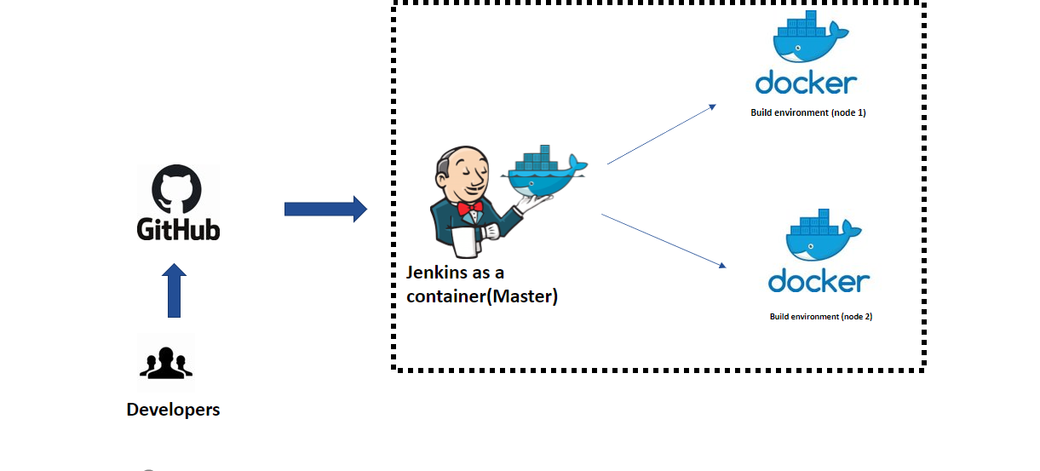

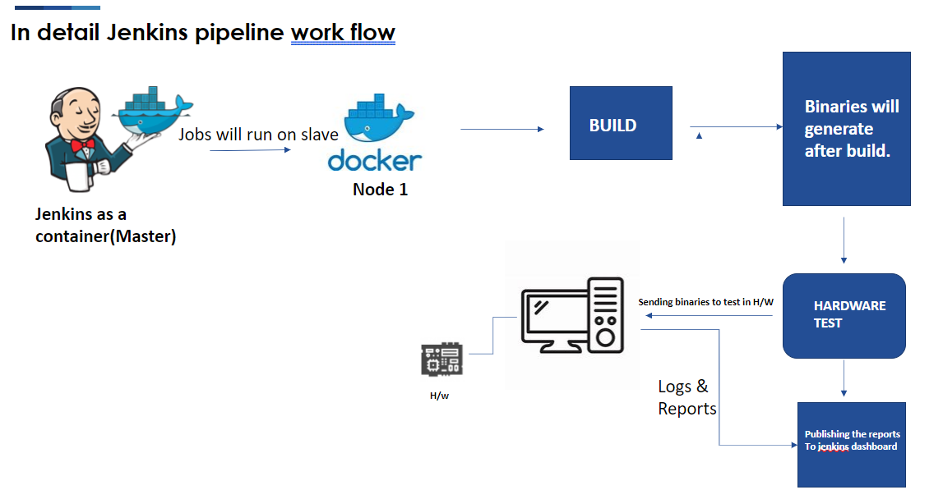

**3.1**.**Detailed architecture workflow:-**

* + Whenever developer push the code source code management (GitHub). Jenkins job will trigger through Poll Scm & some jobs will trigger based on schedules & pull requests.
  + Once job is Triggered, job will run on slave(container).
  + While running the job, it will build the Source code & will get the Binaries.
  + Next stage should be, passing the binaries into a hardware to flash and checking the test cases.
  + Once flashing is done, it will execute the test scripts & will send the reports to Jenkins.
  + Next Stage should be Publishing Artifact & Test case reports into Jenkins Dashboard.

**4 Current Jenkins Workflow in Polaris:**

* In The Polaris Jenkins Dashboard, they have Multiple projects. For Each product they created separate Views in dashboard.
  + - * Daily Builds.
      * Kodiak Monitor.
      * Arnold Monitor.
      * Package Monitor.
      * B1C4 Monitor.
* For each product they monitor the code separately.

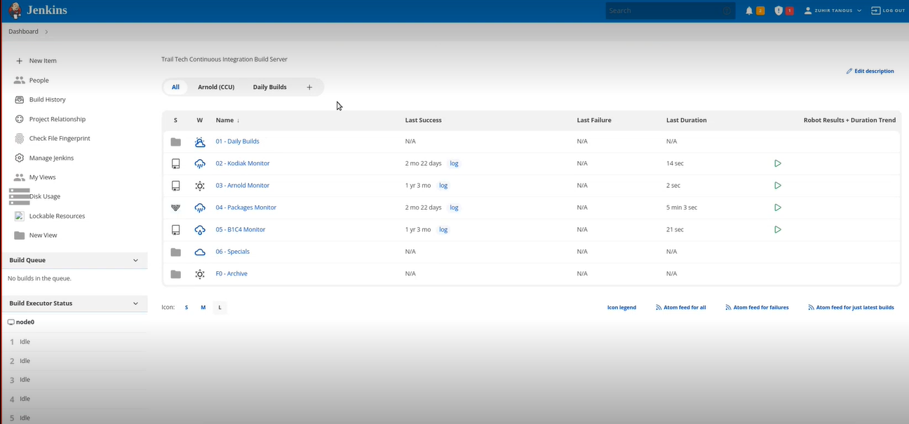

**5. In Detail Explanation on each Views:**

* In each folder they run multiple jobs

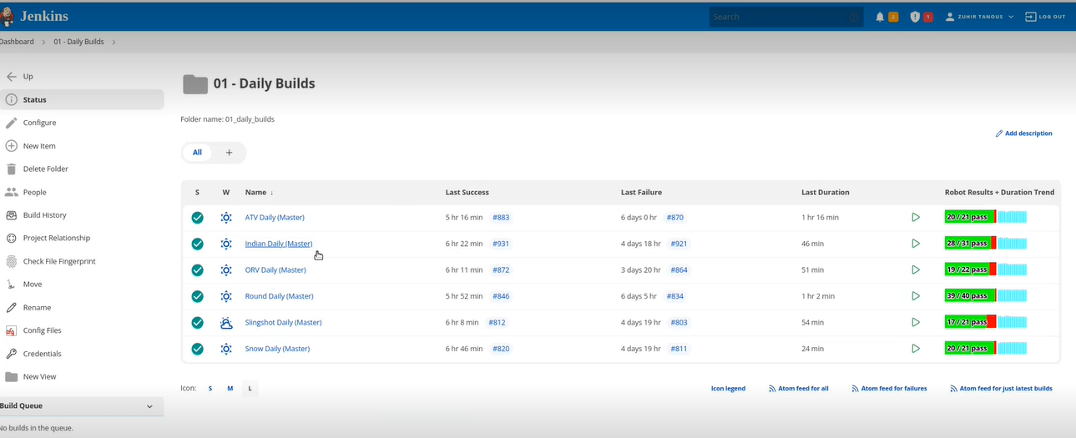

**5.1 Daily Builds**

* Daily builds will trigger twice a day.
* One is 2 AM and another one is 12PM as scheduled by Polaris.
* In the below Screenshot, we can see test results in Jenkins dashboard after successful completion of build.

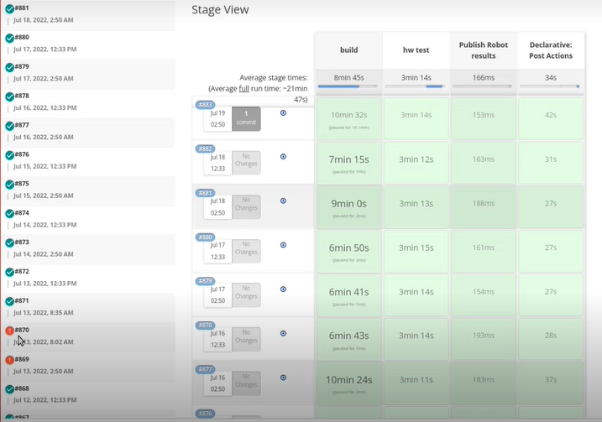

* Here we can check the successful builds and Failure Build status.

**5.2 Test Statistics: -**

Here we can see the test statistics for all the tests.

We can see the test execution logs in the below screenshots.

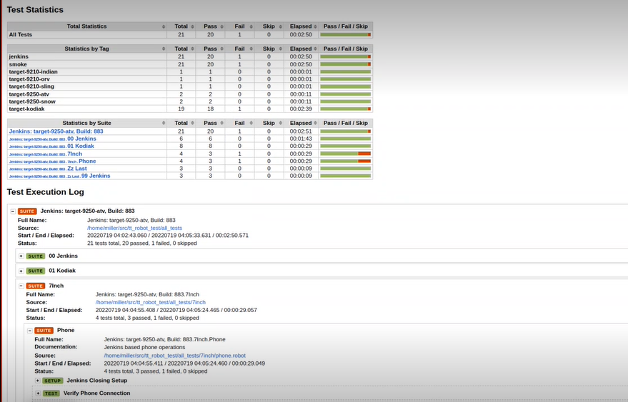

**5.3 Kodiak Monitor :**

* Kodiak Monitor is configured with multibranch pipeline.
* Whenever developers create a branch in the repository, it’ll reflect here and by default it’ll execute the build
* Likewise when developer creates any pull request or commits anything in a particular branch it’ll trigger the builds.
* So everytime anything is pushed into the branch, it’ll build immediately and test.

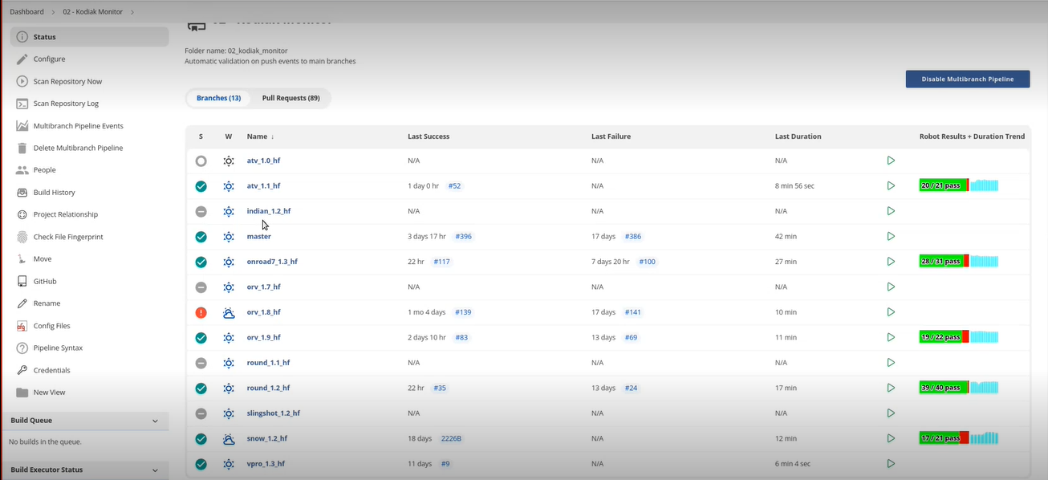

NOTE: Before creating the branch in the multibranch pipeline, it must and should have jenkins file in the particular repository

**5.4 B1C4 Monitor**:

* B1C4 Monitor is configured with multibranch pipeline.
* It is same as Kodiak monitor, the only differene is that there is no hardware testing for this monitor.

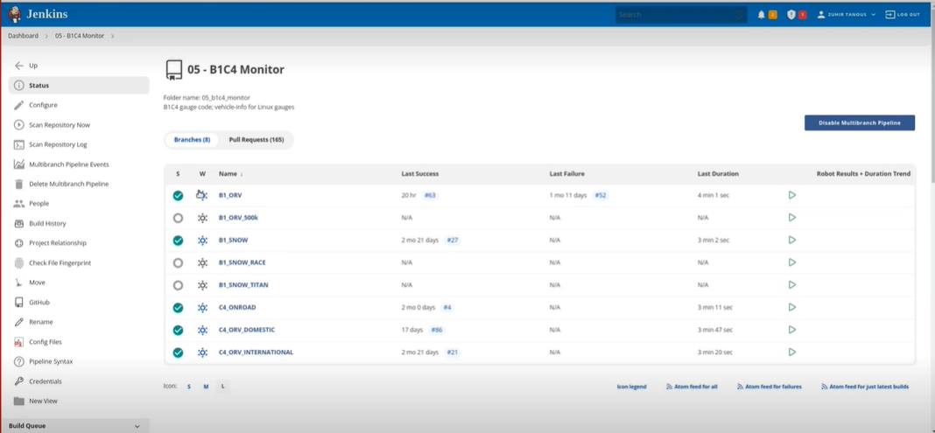

NOTE: Before creating the branch in the multibranch pipeline, it must and should have jenkins file in the particular repository

**5.5 COVERITY SCAN**:

* For ,coverity scan we have separate job for Build & Analysis.
* This job will take a inputs as a parameter ,which module(project) need to build .
* Once build is completed, it will analyze & publish the results into coverity Dashboard

